Improvement Support to Councils - One Public Estate

Purpose:
For information.

Summary
The One Public Estate (OPE) programme has grown since its inception as a pilot programme in 2013 working with 12 council areas, to a large national programme now involving 97% of councils.
This report details the growth and progress of the programme, including the further £180m of Brownfield Land Release Funding currently being administered over three years, 2022/23 - 2024/25.

Recommendations
That IIB notes the progress of the One Public Estate programme.

Contact officer: Ellen Vernon
Position: Programme Director – One Public Estate
Phone no: 07464 652918
Email: ellen.vernon@local.gov.uk

Improvement Support to Councils - One Public Estate
Background
- One Public Estate (OPE) was established in 2013 as a partnership programme between Cabinet Office and the Local Government Association (LGA) in 2013. The programme's aim is to encourage and support collaboration amongst public sector property owners to realise an efficient and effective use of the public estate, in order for local needs such as housing and regeneration to be met by repurposing surplus public assets.

- Additionally, since 2018 the programme has delivered the Land Release Funds, more latterly re-branded Brownfield Land Release Funds (BLRF), on behalf of the Department for Levelling Up, Housing and Communities (DLUHC, formerly MHCLG).

- One Public Estate is jointly delivered by the LGA and the Cabinet Office through a blended team, part working in the LGA and part in the Office of Government Property (OGP), within the Cabinet Office. The programme provides practical and technical support, alongside revenue and capital funding, to public bodies.

- The OPE programme supports 69 council-led OPE Partnerships to develop and deliver portfolios of public property projects comprising:​
  - OPE projects - revenue funding to support central and local government partners to collaborate on shared estate needs and opportunities, exploring options to improve efficiency in the public estate, and to release or repurpose surplus public land
  - LRF/BLRF projects - supporting the release of council-owned brownfield land for housing ​with capital funding to bring surplus local authority land that is suitable for housing to a point of viability and delivery

- To date the programme has administered nine rounds of OPE revenue funding totalling c.£65m, and three rounds of B/LRF capital funding totalling c.£156m.

- In July 2022 OPE launched the first £40m wave of the £180m Brownfield Land Release Fund 2, open for bids until 19th August 2022.

- The programme continues to support both Cabinet Office, and DLUHC, to understand the needs and opportunities related to public land from a council perspective, and to explore, develop and design intervention approaches.

One Public Estate Programme Structure
- One Public Estate operates through a structure of 69 local OPE partnerships. Councils act as the accountable bodies for these OPE partnerships, convening a variety of public bodies in the locality in order to collaborate on public property matters.

- The public bodies involved alongside councils vary by locality, depending on property ownerships and local ambitions, but typically involve blue light bodies, health bodies, and central government departments with a local presence (DWP, MOJ, MOD).

- Each OPE partnership sets a programme of work to review local public property needs collaboratively, in order to identify opportunities for co-locations, public service hubs, and other efficiencies, and with the aim of releasing surplus public land for housing and regeneration purposes. Partners benefit from capital receipts and revenue savings where surplus land can be repurposed, as well as improved public service delivery from co-locating public services. Councils also benefit from the ability to repurpose public land to meet local housing and regeneration needs.

One Public Estate Support
- The OPE programme helps central and local government partners work together to explore and develop joint property projects. Thirteen government departments, 320 councils and hundreds of other public sector bodies, such as health and blue light organisations, are involved.​

- The OPE offer includes financial support, peer support, plus practical and technical advice and brokering from the OPE team. OPE grants typically fund feasibility studies, masterplans and other technical studies, plus local authority capacity.

- To date the programme has administered nine rounds of OPE revenue funding totalling c.£65m and supporting c.750 projects. OPE projects range from station regeneration projects to public service hubs to garden communities.

- These projects are realising significant benefits from OPE investment: delivering capital receipts for reinvestment and reducing running costs for improved public sector efficiency; providing land for homes and jobs; and improving public service delivery.​

  - the ability to link public property to support place agendas – for example town centre regeneration.

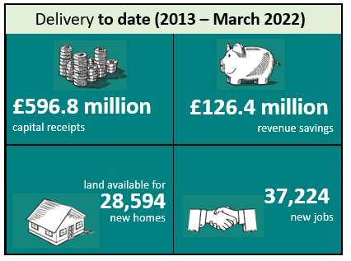

- Equally as valuable have been the softer benefits. These include:
  - enabling local authorities to have some control over the supply of land for housing
  - the ability to support SME’s and local supply chains
  - enabling local authorities to connect and engage with harder to reach parts of government
  - the ability to share problem solving and best practise between councils and other public bodies

- During 2021/22 OPE also provided support to 47 OPE partnerships in the form of the Opportunity Development Fund. This revenue support provided capacity for OPE Partnerships in areas of greatest need to refresh thinking around estate collaboration opportunities post pandemic and develop project pipelines for investment.

Brownfield/Land Release Fund Support
- Since 2018 the Department for Levelling Up, Housing and Communities (and its predecessor MHCLG) have worked with OPE to deliver three rounds of Brownfield/ Land Release Funding, totalling £156m and supporting c.320 projects, through the network of OPE partnerships.

- B/LRF unlocks council-owned sites for housing, particularly brownfield, providing capital funding to address viability issues. Councils are enabled to accelerate the release of land for new homes and deliver housing at pace - to meet local needs such as affordable or extra care homes. Typical works funded include: abnormal costs related to contamination, demolition of obsolete buildings, abnormal utilities costs, highways requirements and so forth.

- BLRF, awarded to councils in 2021/22, also supported 54 council projects to release land for Self and Custom Build plots.

- In addition, OPE has helped DLUHC to pilot an Estate Regeneration scheme, providing capital to 14 council-led estate regeneration schemes.

- LRF projects are expected to deliver 15,663 homes by 2024, with a typical cost of £11,8723 per home enabled. As of March 2022, a number of projects have now released land, with some also having homes now completed.

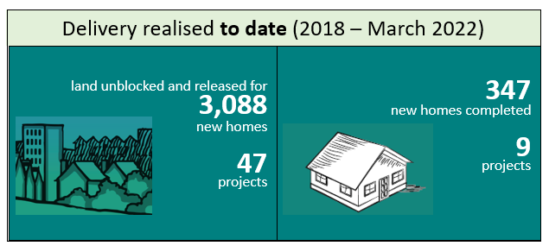

- Case studies of OPE and LRF supported projects are attached at Appendix A.

Activity in 2022/23

- Reflecting the success of the LRF and BLRF1 funding being delivered by the LGA through OPE Partnerships, SR21 saw the announcement of a further £180 million of Brownfield Land Release Funding for spend over the three year SR period.

- The OPE team refined the fund design and criteria to create BLRF2, ensuring the fund was accessible to council areas in need of levelling up, where such councils typically have low land values and had previously struggled to access LRF or BLRF funding. The key differences in the design and criteria of BLRF2 are:
  - the value for money criteria, based on land value uplift, has a lower threshold, meaning councils with lower land values are eligible for funding
  - the fund is now available to Mayoral Combined Authority (MCA) areas, both the MCA and their constituent councils
  - the three year time frame enables councils to plan when to bid to best manage their capacity and resources

- The first wave of BLRF2, £40 million, was soft launched to councils on 30th June 2022, and formally launched on 8th July. The BLRF application window closes on 19th August, with project assessments and funding awards occurring during the autumn.

- Further Waves are planned for years 2 and 3, anticipated to be £60m and £80m respectively.

- The OPE programme is currently holding workshops with councils to provide briefings on the detail of the funds, plus advice on applying.

Summary and Forward Look
- The OPE Programme continues to see strong outputs from the activities and initiatives it is delivering, as evidenced within this report. The model of local OPE partnerships, and the programme's collaborative ethos, mean OPE is an effective and efficient route for reaching and supporting local councils.

- Notwithstanding strong delivery, there are sectoral challenges. Post pandemic, public bodies continue to grapple with the amount, and nature, of property assets required going forwards. Capacity across many areas of the public sector, but particularly built environment professions, continues to present a challenge. Inflation and spiralling energy costs are of increasing concern in relation to public service delivery and built environment projects.

- The OPE Programme is continuing to develop its OPE support offer in response to levelling up and other government priorities, and project opportunities surfaced through local OPE partnership pipeline development.
Issues
- There are no specific issues to raise in relation to the OPE programme. Sector wide issues are set out at paragraph 30 above.
Implications for Wales
- None – the OPE programme only covers English local authority areas. The OPE programme has previously engaged with Welsh Government colleagues to share experiences and learnings.

Equalities implications
- Positive -
  - the OPE programme seeks to support property projects which in general terms improve accessibility to public services for all, and which support local authorities’ to best meet diverse housing needs where the market is unlikely to meet these
  - the criteria to be assessed as part of the current BLRF2 application round include the degree to which the Public Sector Equality Duty is met by proposed schemes (PSED is 5% of the available score)
  - the OPE programme seeks to ensure EDI aims are met operationally, for example through recruitment practises, providing subtitles on video formats, and so forth.
Financial implications
- The OPE programme is delivered by the LGA in partnership with Cabinet Office via a contract. The preceding year’s contract (2021/22) was extended by 3 months to June 30th 2022, to enable a new contract to be put in place for 2022/23. A new contract covers the period 1st July 2022 to 31st March 2023, and has provision for renewal twice, i.e. covering the time period to 31st March 2025.
Next steps
- The OPE programme continues to:
  - Work with OPE partnerships to support previously funded property projects through to delivery
  - Promote, engage, and administer the new BLRF2 fund
  - Work with DLUHC to plan the future waves of BLRF2
  - Work with OGP and DLUHC partners on exploring and developing further interventions and approaches to support housing delivery and public land efficiency.
- From an operational perspective, the OPE programme successfully expanded and restructured the OPE team during 2021/22 to ensure the successful achievement of the larger BLRF programmes, alongside continuing support for OPE funded projects and OPE support offers.

APPENDIX A
ONE PUBLIC ESTATE and LAND RELEASE FUND CASE STUDIES

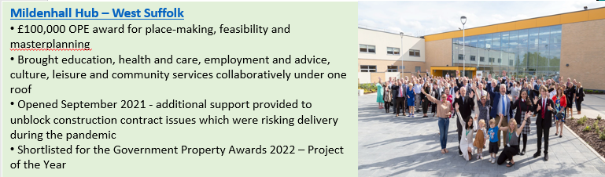
One Public Estate

Brownfield/Land Release Fund
